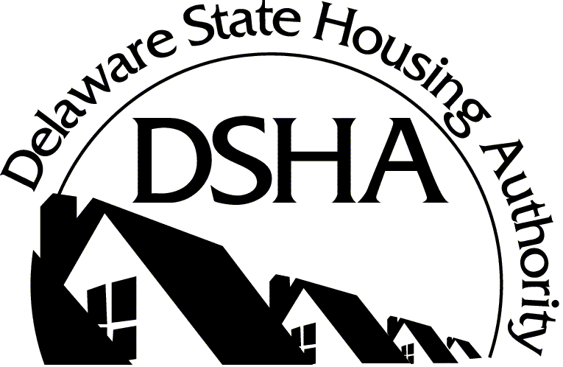
CATALYST FUND
Evidence of Property Condition
Certification Form
This form must be completed by an appropriate local or county official who is qualified to determine the condition of the below named property and will be able to, upon DSHA’s request, provide documentation supporting such condition.
Applicant:
Project: |  |  |  | DE-CF
Property Address:
County: |  | Parcel Number:
The above listed property must meet one of the following conditions to be eligible for the Catalyst Fund program. Please check the appropriate box:
Blighted Structure: a structure is blighted when it exhibits objectively determinable signs of deterioration sufficient to constitute a threat to human health, safety and public welfare. Furthermore, DSHA considers a structure to be blighted if it does not meet the State of Delaware Housing Code or the local building code.
Vacant: a property is considered vacant when it is empty and has been listed for sale for a minimum of one (1) year.
Other: Property does NOT meet any of the above definitions; however, for the reason(s) described below, Applicant requests DSHA consider approving this property for the Catalyst Fund program.

CERTIFICATION: I certify that I have knowledge of the above listed property and its condition and that I have the capacity to make this certification. Documentation supporting this certification will be available upon request, as needed.
Name (Print):
Signature:
Title (Print):
Phone Number:

